|  |
| --- |
| ***Consult Menu***  **Identifier**  UC_01  **Actors**  Visitor (Costumer, Restorer)  **Description**  Everyone can consult menu.  **Preconditions**   * 1. Application has been install.   2. Updated application.   3. The user have choosen the restaurant.   4. Optional (authenficated )   **Asumptions**   * 1. Network connexion etablished.   2. DataBase is online.   3. Restaurant and menus exist.   **Basic course**   * 1. Choose the restaurant on the list   2. Application check hour   3. Application display menu about hour   4. The user can check menu   **Alternante course**  **Case A :**   1. If actor is costumer or restorer and hour is < = 15 AM   Display lunch service  **Case B :**   1. If costumer or restorer and hour is > 15AM   Display evening service  **Case C :**  A.1. DataBase is offline.  Display error message |

|  |
| --- |
| ***Authentification***  **Identifier**  UC_05  **Actors**  Costumer and restorer  **Description**  The user can connect to the Application  **Preconditions**   * 1. UC_2   2. User clicked on « sign in » button   **Asumptions**  1. Account exists  2. Database is online  **Nominal script**  1. User type his ID and password account on form  2. Database is checked with this form  3. Session is created and stocked on BDD  4. User is connected  **Alternative script**  **Case A :**  2. Username is incorrect  Display the error message « Your username doesn’t exist. »  **Case B :**  2. Password is incorrect  Display the error message « Your password is incorrect. »  **Case C :**  2. Username & password are correct AND the type account is CUSTOMER  4.Connected as CUSTOMER UC_20  **Case D :**  2. Username & password are correct AND the type account is RESTORER  4.Connected as RESTORER UC_21  **Inclusion cases**  UC_20 UC_22  **Extension cases** UC_22 if click sign out button |

Proposition SIMON :

Changer => Create account -> Create Customer account (UC_03)/ Create restorer account (UC_04)

Authentification =>   
UC_ 20 Customer account  
UC_ 21 Restorer account

POUR DÉLIER LES INCLUDES.

AJOUTER : DISCONNECT  
🡺 Ca donnerait ceci (??)

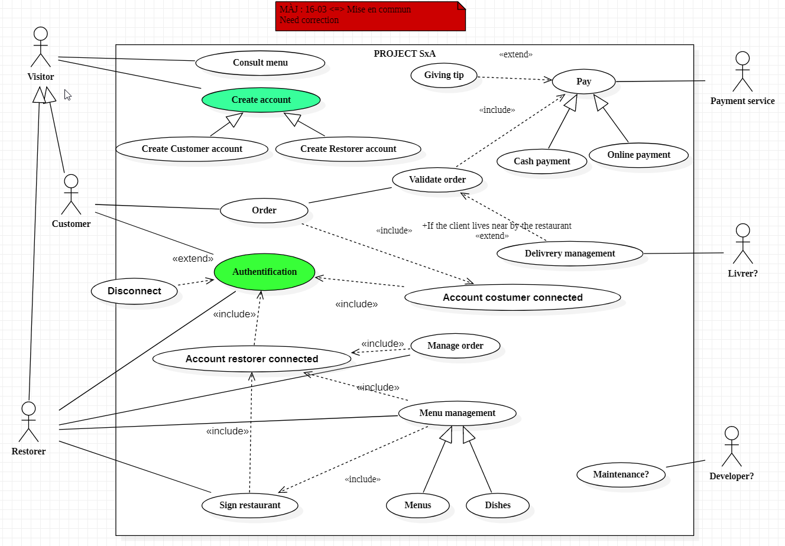

|  |
| --- |
| **Validate Order**  **Identifier**  UC_07  **Actors**  Customer  **Description**  The customer can check and validate his order  **Preconditions**   * 1. UC_06   **Hypothesis**  1. Element checked exist ( menu/hour verified )  **Nominal script**  1. Summary of order on the screen  2. Customer checked his order  3. Order is send to restaurant (UC_16)  **Alternative script**  **Case A :**   * + 1. Costumer want cancel his order Launch UC_23   **Inclusion cases**  UC_08  **Extension cases**  UC_17 if the km <xx ; UC_23 if the costumer click on cancel |

AJOUTER : cancel order UC_23

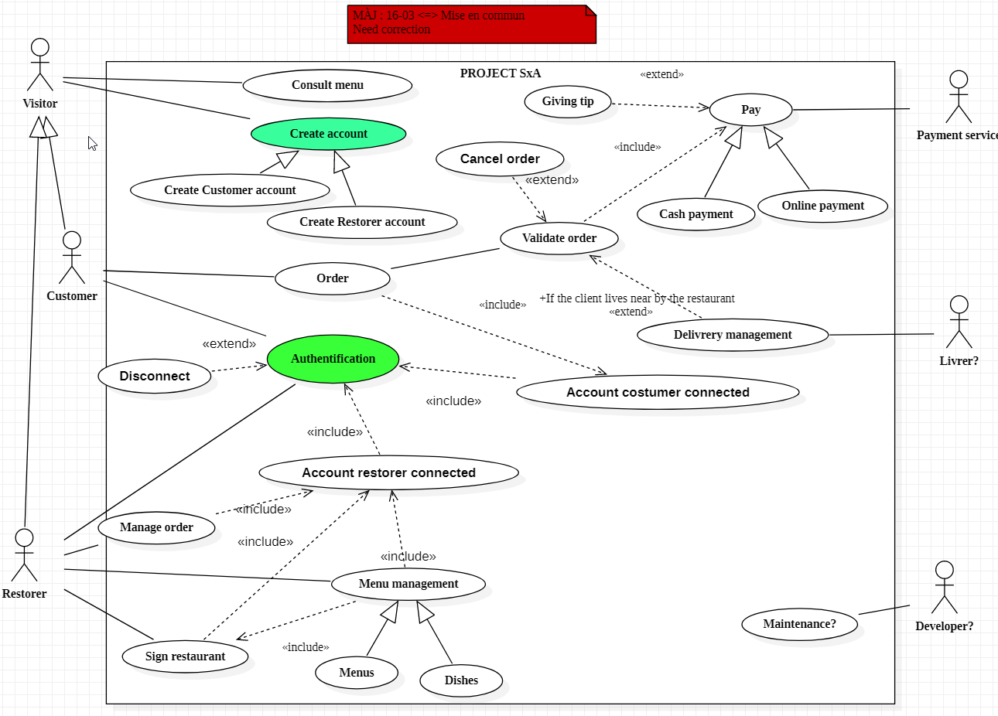

UC_01: Consult Menu (Scénario) --> A

UC_02 :Create account (Scénario) --> S

UC_03: Custommer account

UC_04: Restorer Account

UC_05 : Authentification (Scénario) --> A

UC_06: Order (Scénario) --> S

UC_07: Validate Order (Scénario) --> A

UC_08 : Pay (Scénario) --> S

UC_09 : Cash Paiement

UC_10 : Online Paiement

UC_11 : Giving Tip

UC_12 : Sign Restaurant (Scénario)--> A

UC-13: Menu Management (Scénario) --> S

UC_14 : Menus

UC_15 : Dishes

UC_16 : Manage Order (Scénario)--> A

UC_17 : Delivrery management

UC_19 : Maintenance

UC_20 : Account customer

UC_21 : Account restorer

UC_22 : Disconnect

UC_23 : Cancel order

|  |
| --- |
| **Sign Restaurant**  **Identifier**  UC_12  **Actors**  Restorer  **Description**  A restorer can sign in his restaurant in the platform  **Preconditions**   * + 1. UC_21   **Hypothesis**   * + - 1. Restaurant exists ( exist in real life… )       2. Restorer on form page   **Nominal script**  1. Restorer add his restaurant with a form  2. BDD verification  3. Restaurant is added  **Alternative script**  **Case A :**   1. A field is empty or null   ERROR -> This form is not completed  **Inclusion cases**  UC_21 |

|  |
| --- |
| **Manage Order**  **Identifier**  UC_16  **Actors**  Restorer  **Description** The restorer can manage his order and send to kitchen  **Preconditions** 1. UC_07  **Hypothesis**   1. Validated and payed order   **Nominal script**  1. Restorer have an order list what received   * 1. Can check the order and stock   2. Stock all order   3. Restorer note on paper and send to kitchen   **Alternative script**  **Case A :**  2. Stock is empty ( not food )  Call to the customer  **Case B :**  2. Order has been received twice  Call to the customer  **Inclusion cases**  UC_21 |